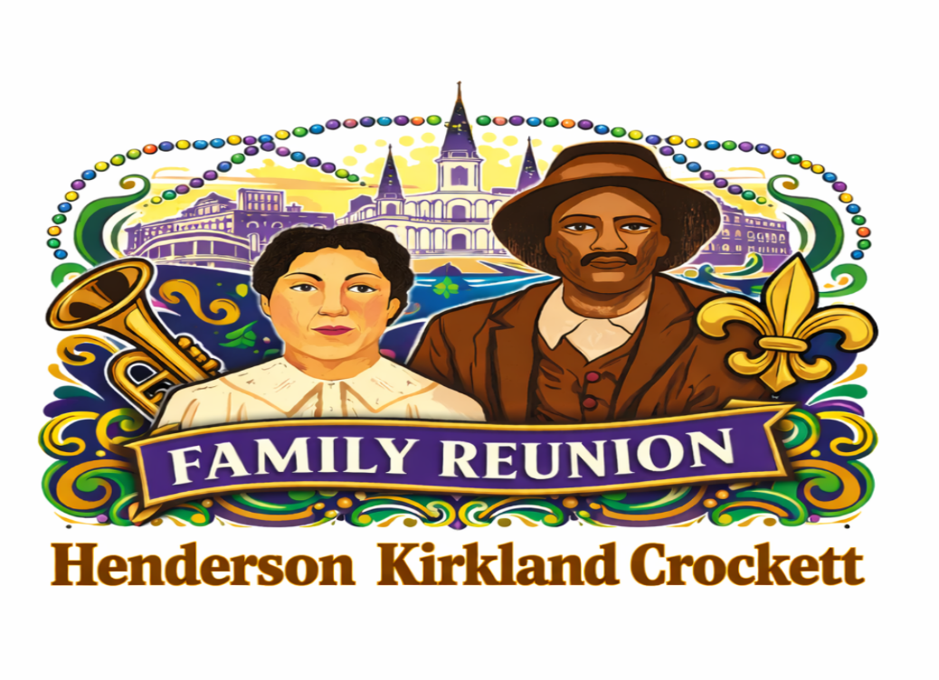
January 31, 2026
Greetings Family,
Warm greetings from Jackson, Mississippi as we prepare for our 2026 Henderson Kirkland Crockett Family Reunion. We are excited to gather once again and celebrate our family, our heritage, and our shared memories. The 2026 reunion theme will be “Dukes and Boots on the Bayou,” honoring our Mississippi roots with a New Orleans flair.

Airport
The Louis Armstrong New Orleans Airport (International Airport)

Location and Hotel Information

Hotel Name: The Jung Hotel and Residences
Address: 1500 Canal Street, New Orleans, LA
Phone Number: (504) 207-9970
Website: https://www.junghotel.com to view amenities
The Jung Hotel is conveniently located near the historic French Quarter and is close to popular landmarks such as the Saenger Theatre and the Canal Street streetcar line, providing easy access to major attractions throughout New Orleans. Reservations must be made no later than June 24, 2026. Any reservations made after this date will be subject to hotel availability and the prevailing rate at the time of booking.

Hotel Room Rates and Reservations: negotiated room rate for the reunion is $89 per night. Please book your rooms early. The earlier you book, the more you can get the room you desire at this good rate. Check-in Time: 4:00 PM and Check-out Time: 12:00 PM

Reunion Fees:
The reunion fees for the Henderson Kirkland Crockett Family Reunion are as follows:
- Adults ages 13 and up: $140
- Children ages 6 to 12: $65
- Children ages 5 and under: Free

Reunion fees should be paid no later than June 24, 2026. Early payment is strongly preferred by June 1, 2026. Please note if you use a Debit Card instead of a Credit Card, hotels tend to add a $100 or more charge/hold for incidentals that will be taken at check-in and reimbursed at check-out (usually not immediate reimbursement). Talk with the hotel representative for details of the exact amount Jung Hotel charges.

Saturday Breakfast Information:
As many of you know, the cost of food has increased significantly from 2025 to 2026. We truly appreciate your understanding as we continue to do our best to find solutions that allow us to accommodate our family and guests as thoughtfully as possible. We will share any updates as they become available.

At this time, up to two guests per room will receive a complimentary breakfast buffet in the hotel restaurant, valued at $25 plus tax per person. Any additional guests in the room may be required to cover the cost of their breakfast. We also understand that some guests may not be able to attend during the Jung Hotel’s designated breakfast hours as they rest on Saturday morning from a fun-filled night.

T Shirt Information
T-shirts must be purchased prior to attending the reunion. Prices may increase for shirts purchased at the reunion site.

Adult T-Shirts: All sizes: $15
Children’s T-Shirts: All sizes: $10

Payment Methods
We will not accept personal checks. Accepted forms of payment to Gladys Madison, 1411 Gibraltar Drive, Jackson MS 39204 include: Cashier’s Check, Money Order, and Bank-to-Bank Wire Transfer (Wells Fargo). We are asking that each State’s Representative to be available to assist your state’s family members with registration if necessary and to send your reunion fees as a group, if possible.
Communication and Registration
We have a WEBSITE!!
We will use the Family’s Facebook page, Kirkland Henderson Crockett, for ongoing communication as needed. The reunion registration form will be posted there, along with information for our new website. We ask that you encourage other family members to join this group. We ask that you LIKE…..COMMENT….and SHARE.

Hard copies of registration packet can be mailed as needed. Please use one of our communication formats:
- State Representatives
- State Committee Members
- hendersonkirklandcrockett2026@gmail.com
- Website: www.henderson-kirkland-crockett-family-reunion-2026.com

Reunion Activities and Schedule
Friday
- Evening Meet and Greet with welcome bag pickup
- Raffle at 8:00 PM
- Night Party Bus 10:00pm (Adults Only)
- Family is welcome to go out and enjoy the nightlife of New Orleans.

Saturday
- Breakfast
- Adventure at your leisure (go to family website for suggestions), family games (included in welcome bag), shopping, dining around town, or touring the city with family.
- Other links to decide your adventures:
  - New Orleans Creole Queen Cruise $47/person (without lunch) and $67 (with lunch), 2 and ½ hour tour.
  - French Market, Magazine Street, Riverwalk Outlets, Local Thrift Stores, Farmer’s Markets. Audubon Park, Children’s Museum, Aquarium, Streetcar Rides.
  - www.nolatourguy.com/free-new-orleans-travel-guide/
  - Digital Visitor Guide: https://digital.milespartnership.com/publication/?m=44526&l=1&p=&pn=
  - Visitacity.com, then key in New Orleans to Create Your Own Tour Guide
- Banquet Dinner Event: 6:00 PM to 11:00 PM
- DJ Savage will be providing music. Please send us requests that you desire to hear prior to the reunion. He will not accept requests on that day. Send your suggested request to our GMAIL account. It does not guarantee ALL requests will be accepted. Thanks.
- Dress code: New Orleans style or however you prefer
- Dancing and Raffles

Sunday
- Buffet breakfast
- Raffle drawing
- Picture Collage, time permitting
- Closing activities and family tributes
Transportation Information
Please note that there will be no personal transportation provided by committee members.
- Rideshare (Uber/Lyft): Pick-up from the designated rideshare area outside baggage claim; typically, 20–30 minutes to downtown depending on traffic.
- Taxi: Flat-rate service to the French Quarter/CBD for up to two passengers; readily available curbside.
- Airport Shuttle (Shared Van): Door-to-door service to hotels and residences; reservations recommended.
- Public Transit (RTA): The Airport Express (E2) bus connects MSY to downtown New Orleans; lowest-cost option, longer travel time.
- Car Rental: On-site consolidated rental car facility with major brands; accessible via shuttle or short walk depending on terminal area.
- Hotel Shuttles/Private Car Services: Jung Hotel does not offer shuttles; private sedans/SUVs can be pre-booked for fixed pricing.
Parking
Please note that valet parking fees at Jung Hotel will apply during your stay at a rate of $50+tax/day.
Is Affordable Parking Available? (price subject to change)
- Premium Parking – 1501 Canal St (Lot P402)
About $12–18 per day
Hourly rates often start around $5–7
- Premium Parking – 1555 Canal St (Lot P407) 2-3 min walk
About $10–16 per day
Often slightly cheaper than the lot directly across from the hotel
- Basin Street Garage (833 Basin St) 5 minute walk
About $10–15 per day
Hourly parking usually $3–5 per hour
One of the more consistently affordable options
- Tulane Med Center Parking Garage (1430 Tulane Ave) 5-7 min
About $8–14 per day
Evening and weekend rates are usually on the lower end
If parking immediately next to or across from the Jung Hotel, download Premium Parking App first—nearly all lots in that corridor use it. ParkMobile App is a good secondary app to have for nearby garages or overflow areas.

We look forward to celebrating together in New Orleans and making unforgettable memories at our 2026 family reunion. With love and anticipation,

The Henderson Kirkland Crockett Family Reunion Committee

Gladys Madison
1411 Gibraltar Drive
Jackson, MS 39204
601-238-0376
hendersonkirklandcrockett2026@gmail.com

Charles (Gloria) McDuffy
816 Reeves Street
Jackson, MS 39204
601-238-0894

Ersula Washington/Marcus Pollard
236 Overlook Circle
Jackson, MS 39213
601-259-9568

Wendy (Christopher) Mickel
529 Boardwalk Blvd
Ridgeland, MS 39157
601-566-3762

Kishina Sanders/Daven Smith
1281 Wooddell Drive
Jackson, MS 39212
601-201-1971

You may fill out these forms below and MAIL to Gladys Madison or email to hendersonkirklandcrockett2026@gmail.com

FAMILY’S LAST NAME: |  |  |  |  | Address:
State: | Zip Code: |  |  |  | Phone #: |  |  |  | E-Mail Address:
First Name |  |  |  |  | Last Name |  |  |  |  | Children  5 yrs. & Under  FREE |  |  |  | Children  6 yrs. – 12 yrs.  $65.00 |  |  |  | Adults  13 yrs. & Older  $140.00
Total Family Reunion Fees Due: |  |  |  |  |  |  |  |  |  |  |  |  |  |  |  |  |  | $
TEE SHIRTS

ADULT – Please Specify Quantity & Sizes

How  Many? |  | Small  ($15.00) |  | How Many? |  | Medium  ($15.00) |  | How Many? |  |  | Large  ($15.00) |  | How Many? |  | X-Large  ($15.00) |  | How Many? |  | XX-Large  ($15.00)
ADULT – Please Specify  Quantity & Size |  |  |  | CHILDREN  Please Specify Quantity & Sizes
How Many? |  | XXX-Large  ($15.00) |  | How  Many? |  | X-Small  2-4  ($10.00) |  | How Many? |  |  | Small  6-8  ($10.00) |  | How Many? |  | Medium  10-12  ($10.00) |  | How Many? |  | Large  14-16  ($10.00)
Total Tee Shirts Fees Due: |  |  |  |  |  |  |  |  |  |  |  |  |  |  |  |  | $

